Section 11 Bootstrap

<https://www.udemy.com/course/the-complete-web-development-bootcamp/learn/lecture/37368626#questions/19976794>

64 what is bootstrap-

2010 CSS framework from twitter

Premade can be implemented easily

12 column layout system

Use CDN link or could DL 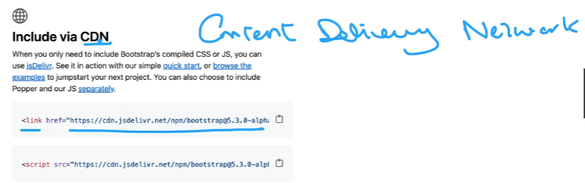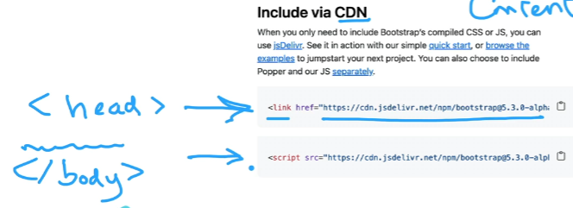

<https://getbootstrap.com/>

65 Bootstrap Layout –

12 col system

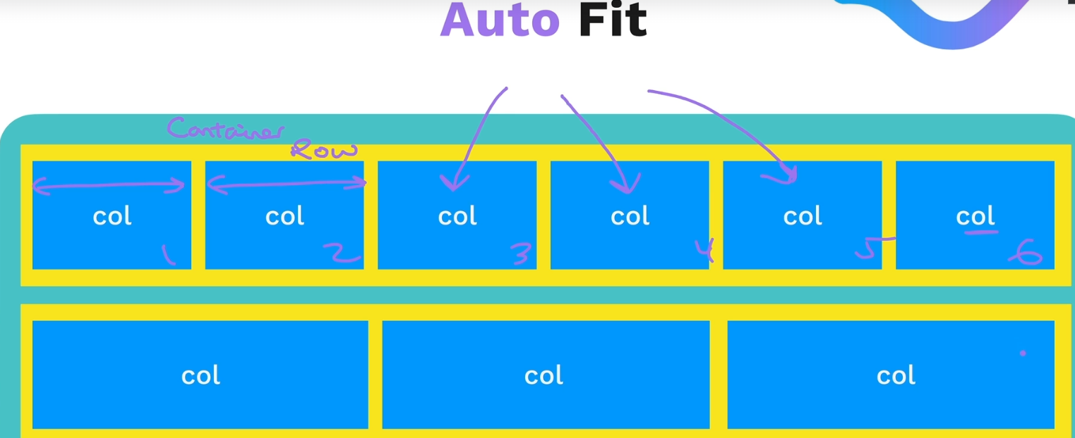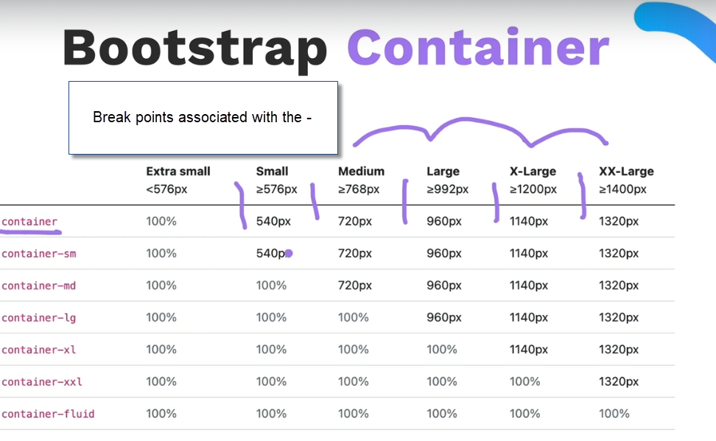

container-fluid is edge to edge behavior

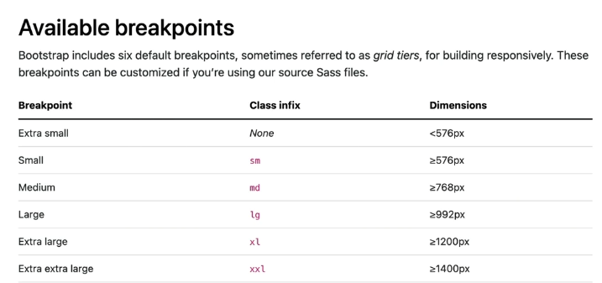

exercises

<https://appbrewery.github.io/bootstrap-layout/>

66 Bootstrap Components -

SVGs are available through bootstrap

Spacing

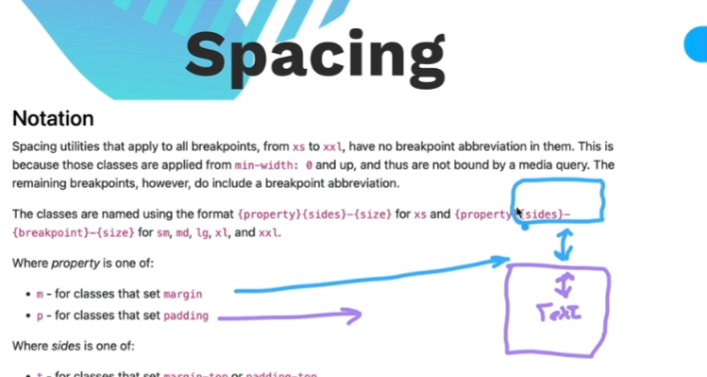



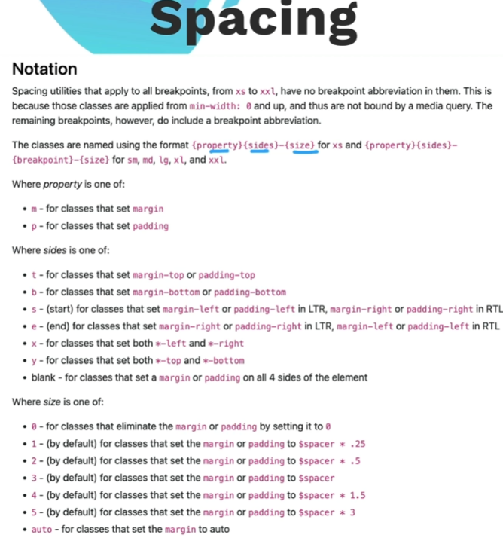

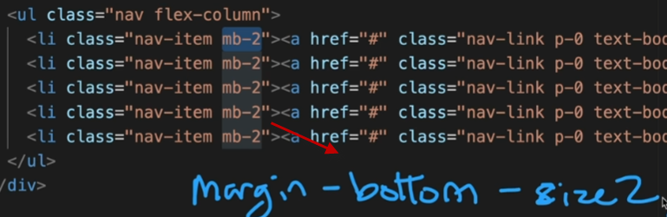

67- TinDog Startup Website Project – Bootstrap themes

<https://www.w3schools.com/bootstrap/bootstrap_templates.asp>

There are people who just make BS Themems and sell them on the internet.

<https://appbrewery.github.io/tindog/>

SVGs – in read me

Restart here

<https://www.udemy.com/course/the-complete-web-development-bootcamp/learn/lecture/37389824#overview>